**AIM:- TO PREPARE PROBLEM DEFINITION FOR HOSPITAL MANAGEMENT SYSTEM**

* **Glossary of Terms :**

1. Administrator - Someone who oversees the website and is responsible for overseeing the data intake and manipulation
2. Application – The main program that the user will be interacting with. This program is made to be user friendly and is located on the website.
3. Patient Need – They can go online and reserve any kind of cab they want from the inventory of available appointment.
4. Graphical User Interface (GUI) – A type of interface that allows the user to interact with the graphical components, including buttons, dropdown menu.
5. Mobile application - Software for an Android smartphone that is available to all users of the cab system.
6. Mobile device - A device that is meant primarily for mobile use, including tablets and smartphones.

* **Project Objectives :**
* **Problem Statement**:
* A system to manage the activities in a hospital:
* Patients request for appointment for any doctor. The details of the existing patients are retrieved by the system. New patients update their details in the system before they request for appointment with the help of assistant. The assistant confirms the appointment based on the availability of free slots for the respective doctors and the patient is informed. Assistant may cancel the appointment at any time.

**Case Descriptions :**

This sample was created in ConceptDraw DIAGRAM diagramming and vector drawing software using the **UML Use Case Diagram** library of the Rapid UML Solution from the Software Development area of ConceptDraw Solution Park.

SYSTEM Design:-

Person could be associated with different Hospitals, and a Hospital could employ or serve multiple Persons. Person class has [**derived attributes**](https://www.uml-diagrams.org/derived-property.html) name and homeAddress. Name represents full name and could be combined from title, given (or first) name, middle name, and family (or last) name.Patient class has derived attribute age which could be calculated based on her or his birth date and current date or hospital admission date.

**Ward** is a division of a hospital or a suite of rooms shared by patients who need a similar kind of care. In a hospital, there are a number of wards, each of which may be empty or have on it one or more **patients**. Each ward has a unique name. Diagram below shows it using **{id}** modifier for ward's name.

Wards are differentiated by **gender** of its patients, i.e. male wards and female wards. A ward can only have patients of the gender admitted to it. Gender is shown as enumeration. Ward and patient have constraint on Gender.

Every ward has a fixed capacity, which is the maximum number of patients that can be on it at one time (i.e. the capacity is the number of beds in the ward). Different wards may have different capacities.

The doctors in the hospital are organised into **teams**(also called **firms**). Each team has a unique name or code (e.g. Orthopaedics or Pediatrics) and is headed by a **consultant doctor** (in the UK, Republic of Ireland, and parts of the Commonwealth) or **attending physician**(also known as staff physician) (in the United States). Consultant doctor or attending physician is the senior doctor who has completed all of his or her specialist training, residency and practices medicine in a clinic or hospital, in the specialty learned during residency. She or he can supervise fellows, residents, and medical students. The rest of the team are all junior doctors. Each doctor could be a member of no more than one team.

Each **patient** is on a single ward and is under the care of a single team of doctors. A patient may be treated by any number of doctors but they must all be in the team that cares for the patient. A doctor can treat any number of patients. The team leader accepts ultimate responsibility, legally and otherwise, for the care of all the patients referred to him/her, even with many of the minute-to-minute decisions being made by subordinates.

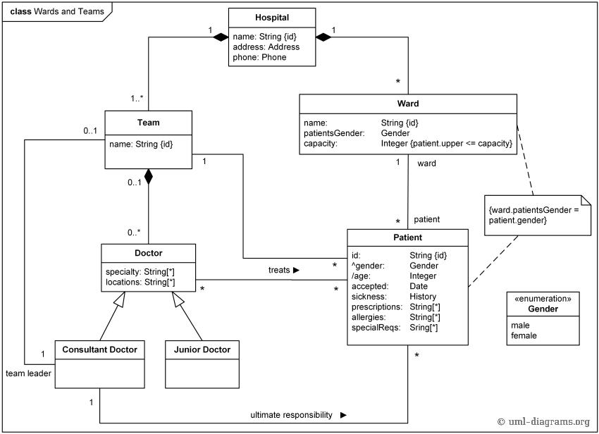

Advantage

1)The integration of the software into our system has made the communication more effective in the health care system. So as a result every data can be accessed any anywhere through authorized log in. Apart from all these the mode of communication has become much cheaper. It has become like no report will be delayed from reaching the right hand of the authorities.

2)      Many limitations have been minimized with the effective use of the technology.  It has been found that geographical limitation in the biggest issue in health care system. This has been intellectually managed with the addition of hospital management system. The reports can be sent through email, instant messages and so no one miss out an evaluation because of that.

Disadvantages

1)One of the greatest disadvantages is related to the security. It is a common matter of concern, if you go online without enough protection that can create big security problem. The data breach is one of the greatest problems of health care industry and is considered as the most sophisticated problem.

2) Another thing is lack of employment. When system becomes automated the chances of employment becomes less or need of the manual drafting of data becomes irrelevant.

Conclusio

Thus we will make problem statement on topic hospital management system.